This blog post will provide an intro to {tvthemes} as well as some  
lessons learned (codecov, Github badges, creating a hexsticker,  
usethis::use_*(), unit testing for ggplot2, etc.) and the future  
direction of the package. I got a lot of good feedback on the colors I used for the  
custom ggplot2 theme and color palettes so I decided to expand it to  
other shows that I love!

pacman::p_load(ggplot2, dplyr, tvthemes, extrafont,

glue, gapminder, emo, patchwork, cowplot)

loadfonts()

**Current list of TV shows**

* **Avatar: The Last Airbender**: theme + palettes (Fire Nation, Water  
  Tribe, Earth Kingdom, & Air Nomads)
* **Brooklyn Nine-Nine**: theme + palettes (regular & dark)
* **Game of Thrones/A Song of Ice & Fire**: ‘The Palettes of Ice &  
  Fire’ (currently: Stark, Lannister, Tully, Targaryen, Greyjoy, &  
  Tyrell)
* **Rick & Morty**: theme + palette
* **Parks & Recreation**: two themes (light & dark) + palette
* **The Simpsons**: theme + palette
* **Spongebob Squarepants**: theme + palette + background images
* *More in future releases…*

**Installation**

Library("tvthemes")

**Fonts**

The difficulty with a lot of the fonts used by TV shows in their logos  
and other marketing media is that they are made by font foundries and  
can be rather expensive (for a regular person like you or me) to  
purchase. So I endeavored to find **free** fonts to use that were  
somewhat similar to the real ones used by the shows from resources like  
Google Fonts. In the documentation you can find the **actual** fonts  
used by the TV shows if you are so inclined to buy them (some are just  
my best guesses though)! In some cases there were fan-made fonts such as  
“Some Time Later” for Spongebob or “Akbar” for The Simpsons that I  
included with the package.

Instead of dealing with extrafont yourself, I re-purposed the  
import_*() functions from the hrbrthemes package so you can import  
the included fonts very easily. Do note that you still might need to  
install the fonts directly on your computer from the .ttf files found  
in tvthemes/inst/fonts. When you’re done running the functions and  
installing the .ttf files on your computer, load the extrafont  
library and then run loadfonts().

The help files for each function tells you the recommended font names in  
case you forget!

import_simpsons() ## "Akbar" font

import_theLastAirbender() ## "Slayer" font

import_rickAndMorty() ## "Get Schwifty" font

import_roboto_condensed() ## "Roboto Condensed" Google Font import from hrbrthemes

import_titillium_web() ## "Titillium Web" Google Font import from hrbrthemes

import_spongeBob() ## "Some Time Later" font

import_cinzel() ## "Cinzel" font to use with 'The Palettes of Ice & Fire'

## install.packages("extrafont")

library(extrafont)

loadfonts() ## You need to do this at the beginning of a session.

**Colors**

I gathered the colors/hex codes by looking at images online or  
re-watching some old episodes and then using various hex code websites  
and hex code extraction websites. Most of the color palettes were pretty  
straightforward as the characters or certain elements of the TV shows  
naturally provided some kind of differentiation by color. The colors in  
some of these palettes may still change from feedback and further  
experimentation.

You can check out all the colors for each palette by running  
scales::show_col(tvthemes:::name_of_palette). Some examples below:

scales::show_col(tvthemes:::rickAndMorty_palette)

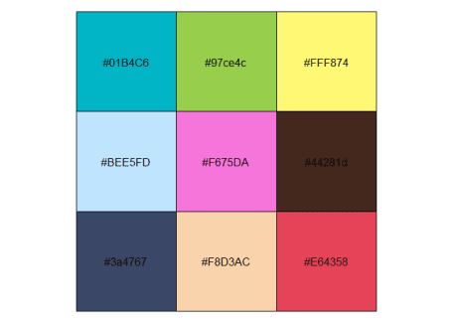

scales::show_col(tvthemes:::lannister_palette)

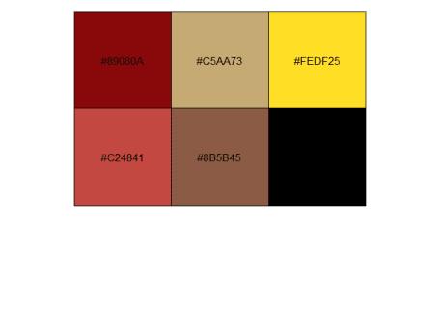

scales::show_col(tvthemes:::simpsons_palette)

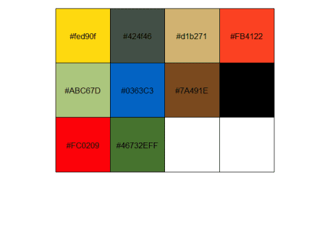

**Example Plots**

**Brooklyn Nine-Nine**

For the most part this theme and palette are unchanged from the original  
blog post. I just added a few more colors to both the normal palette  
(shown below) and the dark palette.

mpg %>%

ggplot(aes(displ)) +

geom_histogram(aes(fill = class),

col = "black", size = 0.1,

binwidth = 0.1) +

scale_fill_brooklyn99() +

labs(title = "Do you know what it means to 'clap back', Raymond?",

subtitle = glue::glue("BE- {emo::ji('clap')} -CAUSE {emo::ji('clap')} I {emo::ji('clap')} DO {emo::ji('clap')} !"),

caption = "Pizza bagels? Pizza rolls? Pizza poppers? Pizzaritos? Pizza pockets?") +

theme_brooklyn99(title.font = "Titillium Web",

text.font = "Calibri Light",

subtitle.size = 14)

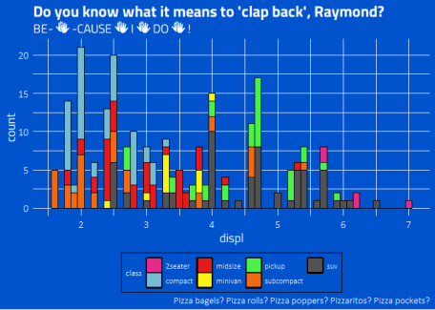

**Spongebob Squarepants**

I had a lot of fun with this one. The colors are taken from the  
characters and their clothes while I was able to find a fan-made font  
that looks similar to the one used in the transition slides of the show.

bobspog_plot <- mpg %>%

ggplot(aes(displ)) +

geom_histogram(aes(fill = class), col = "black", size = 0.1) +

scale_fill_spongeBob() +

labs(title = "F is for Fire that burns down the whole town!",

subtitle = "U is for Uranium... bombs! N is for No survivors when you're-",

caption = "Plankton, those things aren't what fun is about!") +

theme_spongeBob(title.font = "Some Time Later",

text.font = "Some Time Later",

title.size = 22,

subtitle.size = 16,

axis.title.size = 16,

axis.text.size = 14,

legend.title.size = 14)

bobspog_plot

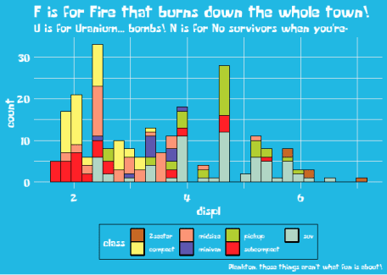

In addition I was inspired by ggpomological::paint_pomological() and  
created a similar function that allows you to place your plot on top of  
a Spongebob-themed background.

paintBikiniBottom(plot = bobspog_plot,

background = "background") ## or "floral"

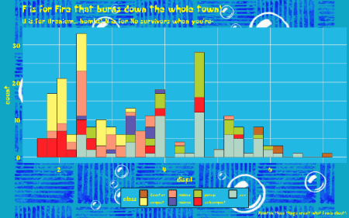

**The Simpsons**

Pretty simple one to do and I’m sure many of you have seen other  
Simpsons related color palettes around the internet.

data <- gapminder::gapminder %>%

filter(country %in% c("France", "Germany", "Ireland", "Italy", "Japan", "Norway", "Belarus")) %>%

mutate(year = as.Date(paste(year, "-01-01", sep = "", format='%Y-%b-%d')))

ggplot(data = data, aes(x = year, y = gdpPercap, fill = country)) +

geom_area(alpha = 0.8) +

scale_x_date(breaks = data$year, date_labels = "%Y") +

scale_y_continuous(expand = c(0, 0), labels = scales::dollar) +

scale_fill_simpsons() +

labs(title = "The Simpsons",

caption = glue::glue("

A 'Bake 'em Away, Toys!' Production"),

x = "Wel-diddly-elcome neighborino!",

y = "Price of Duff Beer") +

theme_simpsons(title.font = "Akbar",

text.font = "Akbar",

axis.text.size = 8)

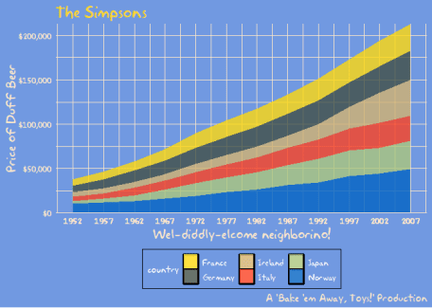

**Rick and Morty**

The colors from the show make for a pretty good discrete color palette  
while the font is a fan-made creation that tries to emulate co-creator  
Justin Roiland’s handwriting that was used on the show.

ggplot(diamonds, aes(price, fill = cut)) +

geom_histogram(binwidth = 500) +

scale_fill_rickAndMorty() +

labs(title = "Dammit Morty, You Know Diamonds Aren't Forever Right?",

subtitle = "They're blood diamonds, Morty **burp**",

caption = "Wubbalubbadubdub!") +

theme_rickAndMorty(title.font = "Get Schwifty",

text.font = "Get Schwifty",

title.size = 14)

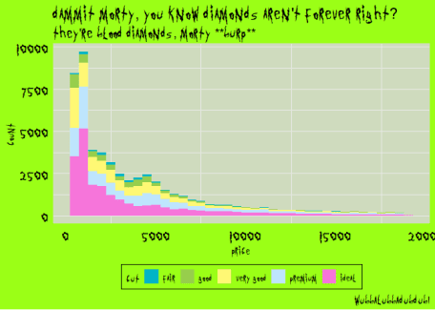

**Game of Thrones: Houses Stark, Lannister, Targaryen**

As a fan of the books and medieval heraldry looking around for  
inspiration for the Great Houses of Westeros was quite fun. I hope to  
add others in the future (Martell, Arryn), even smaller houses if they have a great color  
scheme, like House Bolton, Dayne, Flint (Widow’s Watch), etc.

mpg %>%

ggplot(aes(displ)) +

geom_histogram(aes(fill = class), col = "black", size = 0.1) +

labs(title = "The winters are hard, but the Starks will endure.",

subtitle = "We always have...",

caption = "Winter Is Coming...") +

scale_y_continuous(expand = c(0,0)) +

scale_x_continuous(expand = c(0,0)) +

scale_fill_stark() +

theme_minimal() +

theme(text = element_text(family = "Cinzel", size = 14)) -> stark

colstully <- tully_pal()(5)

ggplot(diamonds, aes(price, fill = cut)) +

geom_histogram(binwidth = 500) +

scale_fill_manual(values = rev(colstully)) +

#scale_fill_tully() +

labs(title = "I've seen wet shits I like better than Walder Frey.",

subtitle = "Pardon my lord, my lady. I need to find a tree to piss on.",

caption = "- The Blackfish") +

theme_minimal() +

theme(text = element_text(family = "Cinzel", size = 10),

title = element_text(family = "Cinzel", size = 14)) -> tully

ggplot(gapminder::gapminder, aes(x = log10(gdpPercap), y = lifeExp)) +

geom_point(aes(color = continent)) +

scale_x_log10() +

scale_color_targaryen() +

labs(title = "I am the blood of the dragon. I must be strong.",

subtitle = "I must have fire in my eyes when I face them, not tears.",

caption = "- Fire & Blood.") +

theme_minimal() +

theme(text = element_text(family = "Cinzel", size = 10),

title = element_text(family = "Cinzel", size = 14)) -> targaryen

## patchwork together:

stark + tully - targaryen + plot_layout(ncol = 1)

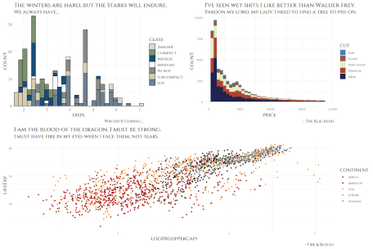

**Game of Thrones: Houses Tyrell, Tully, Greyjoy**

data <- gapminder::gapminder %>%

filter(country %in% c("France", "Germany", "Ireland", "Italy", "Japan", "Norway", "Belarus")) %>%

mutate(year = as.Date(paste(year, "-01-01", sep = "", format='%Y-%b-%d')))

ggplot(data = data, aes(x = year, y = gdpPercap, fill = country)) +

geom_area(alpha = 0.8) +

scale_x_date(breaks = data$year, date_labels = "%Y") +

scale_y_continuous(expand = c(0, 0), labels = scales::dollar) +

scale_fill_tyrell() +

labs(title = "All men are fools, if truth be told, but",

subtitle = "the ones in motley are more amusing than ones with crowns.",

caption = "- The Queen of Thorns") +

theme_minimal() +

theme(text = element_text(family = "Cinzel", size = 10),

plot.title = element_text(family = "Cinzel", size = 16),

plot.subtitle = element_text(family = "Cinzel", size = 12)) -> tyrell

cols <- lannister_pal()(5)

ggplot(diamonds, aes(price, fill = cut)) +

geom_histogram(binwidth = 500) +

labs(title = "You are done with whores.",

subtitle = "The next one I find in your bed, I'll hang.",

caption = "Rains of Castamere") +

scale_fill_manual(values = rev(cols)) +

#scale_fill_lannister() +

theme_minimal() +

theme(text = element_text(family = "Cinzel", size = 14)) -> lannister

airquality %>%

mutate(Month = as.factor(Month)) %>%

ggplot(aes(x = Day, y = Temp, group = Month, color = Month)) +

geom_line(size = 1.5) +

scale_color_greyjoy() +

labs(title = "I am the storm, my lord.",

subtitle = "The first storm, and the last.",

caption = "- Euron 'The Crow's Eye' Greyjoy") +

theme_minimal() +

theme(text = element_text(family = "Cinzel", size = 10),

title = element_text(family = "Cinzel", size = 14)) -> greyjoy

## patchwork together:

tyrell + lannister - greyjoy + plot_layout(ncol = 1)

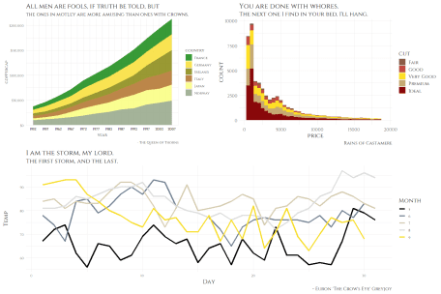

**Avatar: The Last Airbender**

With four very distinct nations (each based on a certain natural  
element) in the Avatar universe it was very easy to come up with color  
palettes.

mpg %>%

ggplot(aes(displ)) +

geom_histogram(aes(fill = class), col = "black", size = 0.1) +

scale_fill_fireNation() +

labs(title = "Flameo, Hotman!",

subtitle = "Fire. Wang Fire. This is my wife, Sapphire.",

x = "Lion Vultures Owned",

y = "Agni Kai Participation") +

theme_theLastAirbender(title.font = "Slayer",

text.font = "Slayer") -> firenation

airquality %>%

mutate(Month = as.factor(Month)) %>%

ggplot(aes(x = Day, y = Temp, group = Month, color = Month)) +

geom_line(size = 1.5) +

scale_color_airNomads() +

labs(title = "Let's head to the Eastern Air Temple!",

subtitle = "Appa, Yip Yip!") +

theme_theLastAirbender(title.font = "Slayer",

text.font = "Slayer",

title.size = 10) -> airnomads

ggplot(gapminder::gapminder, aes(x = log10(gdpPercap), y = lifeExp)) +

geom_point(aes(color = continent)) +

scale_x_log10() +

scale_color_waterTribe() +

labs(title = "I am thinking maybe we could... do an activity together?",

subtitle = "... Do an activity?",

x = "GDP per Otter-Penguins",

y = "Life Expectancy of Arctic Camels") +

theme_theLastAirbender(title.font = "Slayer",

text.font = "Slayer",

title.size = 8,

subtitle.size = 8) -> watertribe

mpg %>%

ggplot(aes(displ)) +

geom_histogram(aes(fill = class), col = "black", size = 0.1) +

scale_fill_earthKingdom() +

labs(title = "There is no war in Ba Sing Se",

subtitle = "(Welcome to Lake Laogai)") +

theme_theLastAirbender(title.font = "Slayer",

text.font = "Slayer",

title.size = 14) -> earthkingdom

## plot together:

plot_grid(firenation, airnomads, watertribe, earthkingdom, ncol = 2)

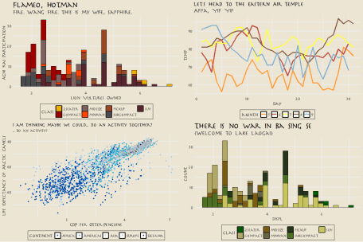

**Parks and Recreation**

This is probably a more literal interpretation of “Parks and Recreation”  
rather than any of the colors in the palette/theme representing the  
characters. This one was the one I took the most liberties with and just  
tried to use colors that felt very outdoorsy and “Parks”-like. The font  
used with this theme, “Titillium Web” is similar to the typeface used in  
the logo of “Parks and Rec”, “Champion HTF-Heavyweight”.

airquality %>%

mutate(Month = as.factor(Month)) %>%

ggplot(aes(x = Day, y = Temp, group = Month, color = Month)) +

geom_point(size = 2.5) +

labs(title = "Calzones are pointless.", subtitle = "They're just pizza that's harder to eat!",

caption = "No one likes them. Good day, sir.") +

scale_color_parksAndRec() +

theme_minimal() +

theme_parksAndRec(text.font = "Titillium Web",

title.font = "Titillium Web Black",

legend.font = "Titillium Web") -> parksandrec

mpg %>%

ggplot(aes(displ)) +

geom_histogram(aes(fill = class), col = "black", size = 0.1) +

labs(title = "Parks & Recreation",

subtitle = "Gotta Spend Money To Make Money!",

caption = "And I spent... all of my money!") +

scale_fill_parksAndRec() +

theme_minimal() +

theme_parksAndRec_light(title.font = "Titillium Web Black",

text.font = "Titillium Web") -> parksandreclight

## plot together:

plot_grid(parksandrec, parksandreclight, ncol = 2)

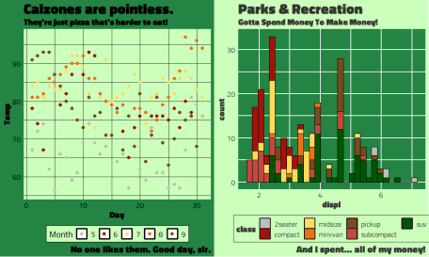

**Lessons Learned & Future Steps**

Although this package is mainly just for fun, I still learned quite a  
lot from the experience. I was able to get more practice with usethis  
and devtools for package development. Instead of manually creating  
package files, be it the DESCRIPTION, R scripts, license, etc. the  
usethis::use_*() set of functions creates them for you automatically  
along with the correct directories and when relevant adds them to  
.gitignore or makes a note of any changes in other relevant files.  
Below is an example of a really nifty usethis function that creates a  
unit test to run a spell check on all your documentation!

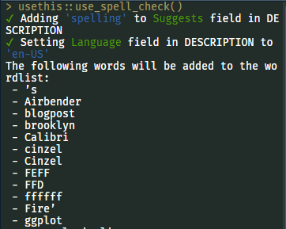

A lot of the best packages I’ve seen have always had the cool and  
informative badges at the top of the README. The other badges I have on tvthemes  
are the ones for the license (GPL v3) and for codecov. I just used  
usethis::use_badge() but there are alternative ways to produce the  
badges such as the badger  
package.

On the topic of testing, I create a lot of unit tests for the R packages  
that I help maintain at the NGO I work for but until tvthemes I had  
never created tests for ggplot2 themes and palette objects before.  
After looking around at other theme/palette packages such as  
vapoRwave,  
hrbrthemes, and  
ggpomological I was able  
to get a sense for what to test for such as:

Library(badger)

Library(vapoRwave)

Library(hrbthemes)

Library(ggpomological)

test_that("theme_brooklyn99 works", {

thm <- theme_brooklyn99()

expect_s3_class(thm, "theme")

expect_equal(thm$text$family, "")

})

test_that("brooklyn99_pal raises warning with number greater than colors available, x > 10", {

expect_warning(brooklyn99_pal()(11))

})

Although all of the actual theme or palette functions are “covered” I  
could still add more depth to them. Currently I only have a test that  
checks for one component of the theme, the font family, but I should  
expand this to include other key components of the particular theme I’m  
testing for. For example, the exact color of the panel.background for  
theme_spongBob() or the correct default size of the title. I also need  
to figure out how to write tests for the import_*() functions and the  
add-background-to-plot paintBikiniBottom() function!

The next thing I want to try out is to use the  
vdiffr package to test the outputted  
plots themselves. From the README the steps are as follows:

1. Add expectations to by including expect_doppelganger() in your  
   test files.
2. Run manage_cases() to generate the plots which vdiffr will test  
   against in the future. This will launch a shiny gadget which will  
   ask you to confirm that each plot is correct.
3. Run devtools::test() to execute the tests as normal.

This can be extremely useful for tvthemes to check whether the  
individual themes and palettes are being applied properly whenever I  
make some changes in the code!

Last, but certainly not least, was the hex sticker for my package.  
Originally I wanted to use a character from one of the TV shows in the  
logo but in the end I went with something that wasn’t copyrighted. Also,  
I didn’t really have the photoshop skills to make it work! What I ended  
up choosing was using the popular Japanese site,  
[irasutoya](https://www.irasutoya.com/), which provides thousands of  
drawings for free use. It’s a great website that provides drawings for  
any object, person, and situation! After finding the best image (a child  
watching cartoons and sitting too close to the TV), I used the  
hexSticker package by Guangchuang Yu to create it in R:

## Download image:

download.file("https://3.bp.blogspot.com/-kHda-2huAF8/WUdZKshMQkI/AAAAAAABFDM/sXt-PT9dKtYp2Y0Y_OV64TJzs7PvOLZmgCLcBGAs/s800/tv_boy_chikaku.png",

destfile = paste0(tempdir() , ".png"), mode="wb")

## Create sticker:

hexSticker::sticker(subplot = paste0(tempdir() , ".png"),

package = "tvthemes",

p_size = 14, p_color = "#8B4411",

p_x = 1, p_y = 1.65,

s_x = 1.0, s_y = 0.95,

s_width = 0.6, s_height = 0.6,

h_fill = "#f5f5dc", h_color = "black",

filename = "tvthemes_hexsticker.png")